**CREATE A STATIC WEBSITE USING JEKYLL**

**Deploying: Overview**

In this course, you’ll learn how to deploy a [static site](https://en.wikipedia.org/wiki/Static_web_page) to the Internet.

What exactly do we mean by *deploy*, or *deploying*?

Deploying means making content or software accessible and available for use.

The website that you’ll deploy in this course will be public, or “live”, on the Internet. It will be accessible to anyone (with open Internet access), at anytime, anywhere in the world.

By the end of this course, you will have:

1. Generated a static site
2. Deployed it to the Internet
3. Given the website a custom domain name

Let’s begin!

**Instructions**

The diagram to the right illustrates the three main steps we’ll cover in this course — (1) generating the site, (2) deploying it to the public Internet, and (3) assigning it a custom domain name. We’ll walk through each of these steps in the order they appear on the diagram.

**Note:** We’ll make extensive use of the command line and Git in this course. If you need to review, check out the corresponding Codecademy courses:

[Learn the Command Line](https://www.codecademy.com/learn/learn-the-command-line)

[Learn Git](https://www.codecademy.com/learn/learn-git)

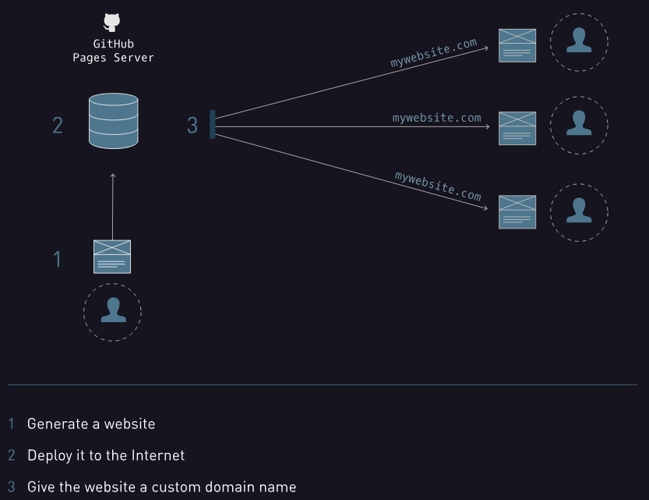

### Jekyll: Overview

The focus of this course will be on the process of deploying a website, not on actually creating a website.

We’ll use a popular tool known as Jekyll to quickly generate a website. This will help keep the focus on the deployment process and quickly provide you with content to deploy, rather than focusing solely on website creation.

Jekyll is a simple static site generator. Using Jekyll is a very common way of generating a “ready-to-publish static website” within seconds. You can learn more about Jekyll [here](https://jekyllrb.com/docs/home/).

**An important note:**

The reason this course uses Jekyll is so that we can generate the static website quickly and focus on deploying it. However, we understand that you may not want to use the Jekyll-generated content.

In that case, it is possible to follow all of the steps outlined in this course with your own content — just make sure that your HTML is inside of a file called **index.html**. As you’ll see, even Jekyll uses a file called **index.html**.

If instead you’d like to learn about creating static sites (starting from scratch), check out our [Make a Website](https://www.codecademy.com/learn/make-a-website) course.

### Instructions

Take a look at the sample site in the browser to the right.

By the end of this unit, you’ll have your own Jekyll-generated website ready to deploy.

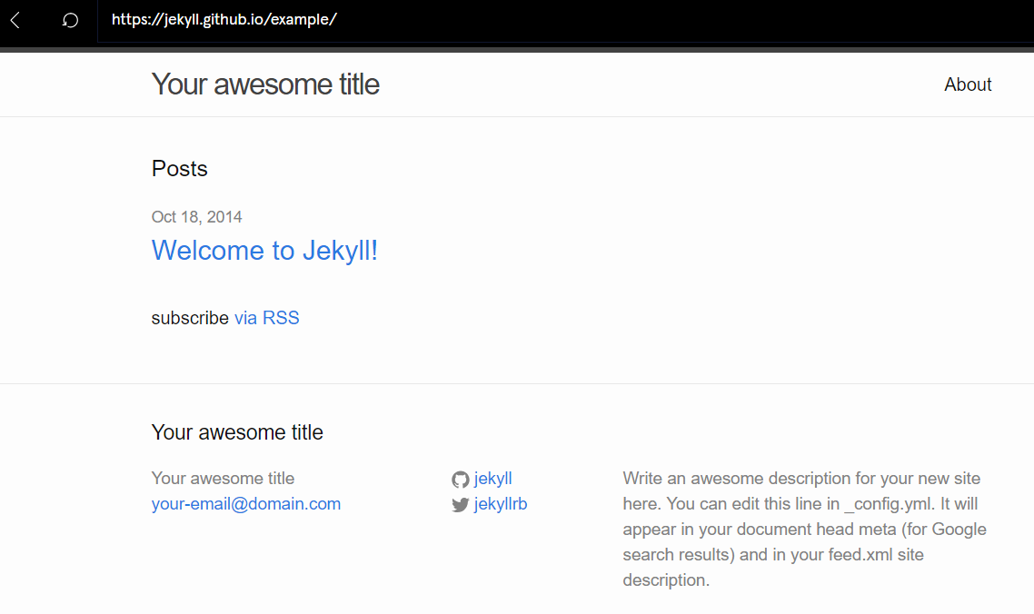

**Installing Jekyll**

Before we can generate a website, we must install Jekyll.

Jekyll is a Ruby gem (also known as a [RubyGem](http://guides.rubygems.org/what-is-a-gem/" \t "_blank)) and can be installed from the command line. Don’t worry, knowledge of Ruby is *not* required in order to complete this course.

Once Jekyll is installed, we can use it to generate your website.

**Instructions**

Checkpoint 1 Passed

**1.**

Install Jekyll by typing the following command in the terminal:

gem install jekyll

Wait for the gem to finish installing before moving onto the next exercise. A successful install will display the following:

Successfully installed jekyll-3.1.3  
Parsing documentation for jekyll-3.1.3  
Installing ri documentation for jekyll-3.1.3  
Done installing documentation for jekyll  
1 gem installed

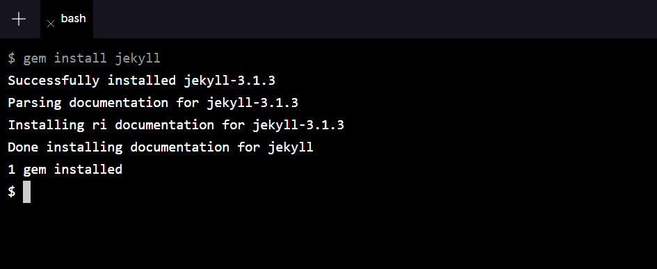

**Generate a Static Site**

Great! Now that Jekyll is installed, let’s generate your website.

To do so, we’ll use Jekyll’s new command and specify a directory name. The directory will contain all of your site’s default content that can be customized later.

For example, to generate a website in a directory called my-portfolio-site, we can type:

jekyll new my-portfolio-site

The command will create a directory called my-portfolio-site and fill it with Jekyll’s site content.

**Note:** We’ll use the directory name my-portfolio-site in examples throughout the course. Don’t worry about the details of the directory structure just yet, we’ll give an overview in the upcoming exercises.

**Instructions**

Checkpoint 1 Passed

**1.**

In the terminal, use Jekyll’s new command to generate your static website with a directory named personal-website.

Checkpoint 2 Passed

**2.**

Use the ls command to verify that the directory was successfully generated.

**Note:** The first character of the ls command is a lowercase L, *not* the number 1.